The Accidental Producer:
Using Hidden Talents to Extend Reference via Podcasts

Susette Newberry, Kaila Bussert, Michael Engle
Department of Collections, Reference, Instruction and Outreach
Cornell University Library

“Beyond the Desk”
6th Annual Reference Services Symposium
Columbia University
March 14, 2008

Introduction

In 2007, librarians from Cornell University’s social sciences and humanities libraries launched a program to promote reference and other library services via podcasting. As a relatively new technology, podcasting offers a way to distribute content over the Internet for use on computers and mobile devices. The process of producing podcast episodes involves writing scripts, recording and editing audio, adding images and music, and bringing it all together in an engaging package—all skills honed for decades by radio and film producers, but not generally taught in library school.

Cornell podcasters went on to develop several podcast series, each differing in its style, length and target audience. The first series, Uris Historical Tours, comprises six audio walking tours of Cornell’s first library. Designed as a form of cultural programming and outreach to alumni and friends, the audio walking tours have become popular with patrons on- and off-site. The second series, orientation walking tours, serves new students and faculty members by describing collections and reference services. While the historical tours were well received, the orientation tours garnered little use. After a period of assessment, the team concluded that their orientation tours simply did not offer a production style that appropriately matched content with audience expectations and needs. With these lessons in mind, podcasters developed Research Minutes, a series for undergraduate students covering library research concepts. The series transforms the library’s web-based research tutorial and skills guides into short, ninety-second podcasts that incorporate music, images and humor. Integrating key aspects of public service, podcasting has proven itself an ideal method to unite reference, outreach, and instruction.

Building a Framework

The Department of Collections, Reference, Instruction, and Outreach (CRIO) is housed in Olin Library, Cornell’s main social sciences and humanities library. In addition to reference, instruction and collection development responsibilities, all department members are expected to be active in outreach to a variety of library constituents and strive to increase awareness of our services among Cornell community members and remote patrons. We were drawn to podcasting as a communications medium primarily because of its potential to reach beyond our doors to offer library services to our users in their own spaces.

At the core of podcasting is its ability to distribute digital media files (audio and video) over the Internet using syndication feeds for playback on portable devices such as iPods or simply on personal computers. Podcasts (audio-only programs, and their multimedia versions, vodcasts) can be individually downloaded or streamed on the Web, or they can be syndicated so that subscribers can automatically download new episodes as they become available. This means that unlike traditional radio broadcasts, users can download, then listen to (or view) podcasts at their own convenience and point of need. We identified the great potential of podcasting to deliver research information to a new generation of students who use portable electronic devices, and who are accustomed to accessing multimedia content on their own schedules, at their own convenience. Knowing that college students are heavy consumers of visual media, we developed and implemented a podcasting program to serve the department’s instructional and communications objectives, beginning with a pilot project. During this initial phase, we constructed a technical framework for podcasting, planning to use our new skills to implement instructional and reference-related podcasts.

Historical Tours

The pilot phase produced a series of five episodes on the history and architecture of Uris Library, Cornell’s oldest library, and debuted during Cornell’s alumni reunion weekend in June 2007. The podcast was planned as a form of cultural programming, to exist as sound files and in an online exhibition—a web resource of sound files and text, historical quotations, Cornell narratives, images, and links to related print and electronic resources. This first incarnation of the podcasting program was also designed to function independently from the web site as a series of audio-only walking tours. We evaluated a number of cultural podcasts and developed a style of writing, narrating and packaging based primarily on the art museum, or “acoustiguide”-style tour that would offer visitors a polished, informative narrative. In order to transform the written curatorial text into a functioning podcast series, we learned a variety of new skills.

We researched audio recording equipment, including digital audio recorders, microphones, mixers, editing software, and file formats. After purchasing recording equipment, we were able to capture high-quality sound, knowing that later file compressions would degrade the sound quality. We sought out a suitable recording space, learned how to control a sound mixer, and edited audio using Audacity, an open-source tool. Finally, we learned about RSS feeds, online services for delivering and monitoring feeds, and podcast delivery software so that we could promote and syndicate our podcasts.

Creating podcasts involved learning new technical skills, but also allowed us to discover and leverage hidden talents of individual librarians. Our foray into digital audio recording revealed that our colleagues had a range of talents and relevant experience they were pleased to dust off and contribute to the effort. Several reference librarians were experienced narrators: a former children’s librarian who specialized in reading aloud, three former college radio DJs, and a poet. Others had musical training, which proved to be especially helpful for sound editing, and audiophiles helped in fine-tuning during the mixing process—all skills that contributed substantively to production values. We elicited controlled, but varied, vocal expression from our narrators, and developed a studio-like recording environment for clean, natural sound, to enhance the in-person, curated tour experience. We archived the series in eCommons, Cornell’s DSPACE-driven digital repository, and delivered it on LibeCast (a web site featuring Cornell’s library-sponsored podcast series), and on iTunes and other free commercial distribution venues. In addition, the tour was loaded onto circulating MP3 players for self-guided walking tours of the building. Our first attempt at podcasting was a resounding success, which we witnessed in person and monitored using several web usage statistics-gathering methods. More important, the pilot project established a framework for CRIO’s podcasting program.

Orientation Tours

Throughout the process of creating and launching the first series, our podcast team aimed to use the medium to expose collections and enhance reference services. Thus, orientation walking tours for new students and faculty members seemed to be the next logical step. In drafting scripts to cover three adjoining libraries, we re-examined writing, vocal and musical styles to create a multi-part tour that would offer consistency, clarity and depth. Although still inspired by the museum tour model, we rewrote scripts, providing directions and information, highlighting collections, facilities and services. Recognizing that written texts do not necessarily sound good, we knew our biggest challenge would be to make the tour engaging for busy listeners. We even added the alma mater.

Several weeks later, we reviewed statistics for online use of the orientation tours as well as for circulation of the MP3 players and discovered that they were used very little. After assessing our online distribution and in-print publicity methods, we concluded that the style that had been so important to the success of the first series simply did not work for the orientation tours: the podcasts were too long, the museum style too highbrow, and that as audio tours only, they had limited appeal for a multimedia savvy audience.
Research Minutes: Becoming Multimedia Savvy

Our response to the challenge was to produce Research Minutes, a multimedia vodcast designed to deliver reference and instructional content to undergraduate students at Cornell. Each segment is short, as declared in the opening line: “ninety seconds of research tips for you—the busy student—from us, the librarians.” The format follows a reference interview in which a friendly librarian helps a student with a typical research problem. Many students today arrive at college with sophisticated visual literacy skills. They are already skilled at processing a great deal of non-verbal information, and have grown to expect that words are accompanied and enhanced by images. We recognized that we could create visual content that would appeal to our students and capitalize on their information-processing habits. Thus, we felt that the multimedia format was well suited to teach complex information literacy skills, such as recognizing the difference between scholarly and popular articles. We wanted to transform library instructional material originally conceived as straight-out text into a visual medium that communicated information efficiently, and in so doing, engage our multimedia savvy students.

Producing Research Minutes involved transitioning from the format of radio to the arena of television and movies by incorporating many different elements: images, animation, music, and narration. We worked with the library’s communications team to create an animation of a dancing clock tower, a caricature of Cornell’s iconic bell tower, which is attached to Uris Library. With the animation framing each segment’s beginning and end, we used a large number of images to create, in essence, an entire animated sequence. We also aimed to keep it light and humorous. Visual humor in the form of fun typography, speech balloons, and cartoons enlivened the tone, as did the music. We chose an arrangement of Rimsky-Korsakov’s Flight of the Bumblebee, a fast-tempo piece that fits perfectly with the theme and tagline of Research Minutes. Once we appreciated the extent to which we brought our many new technical skills together as storytellers, we were ready to become directors and meld content, style and format.

From Script to Screen

One of our department’s primary instruction goals is to encourage students to think through, step by step, the tasks involved in taking on a serious research project. Cornell reference librarians have collectively developed a research tutorial that teaches the critical evaluation of sources and information. Part of that tutorial is a research guide for undergraduate students published in print as “Distinguishing Scholarly from Non-Scholarly Periodicals,” and adapted as a web page in 1995. Over the last several years, this specific web page has seen heavy use (over 50,000 hits in the 2005-06 academic year, numerous requests for permission to adapt, and uncounted uses of our Creative Commons license), which suggested to us that it would make an excellent Research Minute. For the first Research Minute, we focused on teaching how to recognize scholarly journals. For the second segment, we demonstrated how to distinguish substantive news sources from popular news sources.

The subjects of our first two episodes lent themselves easily to transformation. Scholarly and peer-reviewed journal articles have a broadly predictable appearance and similar content features. Likewise, substantive news sources share a broadly similar appearance that distinguishes them from both scholarly sources and from popular magazines. The ability to distinguish scholarly publications from other information sources is a basic information literacy skill. Because students should be able to recognize scholarly articles, we used visual cues to teach them to identify and evaluate publication genres. These cues are the initial indicators of the authority and accuracy of articles. A multimedia vodcast conveys that information very well.

Adapting the content for vodcasts required us to intensively edit and rewrite a portion of guide text. We were able to fit that content into two ninety-second segments by communicating some of it visually. We chose images of an article from a scholarly journal for the first podcast and a news article for the second. We illustrated the verbal points with graphics that highlighted the abstract, the contact information for the authors, the extensive bibliography, and the general look and feel of a scholarly journal. By adding more images to simulate the reference interview, we were able to fully illustrate the narrative: the physical location of a reference desk, a friendly and open interaction between librarian and student, and librarians as accessible information guides. All of this can be communicated economically without words, reinforcing and augmenting the verbal parts of the script. Research Minutes incorporates many different elements—images, animation, music, and narration—to deliver instructional content.

Distribution

Because we want to maximize chances that students will discover our multimedia productions, we have put significant effort into distributing access. We simply cannot expect students to ferret through our complex web sites to find hidden movies. Thus, we promote and insert Research Minutes in many online venues: through the library web site, as a component of course web pages, on the university’s course management system, and on commercial sites like YouTube. We continue to assess the effectiveness of and methods for distributing these first podcasts and plan to apply the lessons we learn to future segments.

As new media become available, our teaching tools will continue to evolve, but the essential content of our instruction remains remarkably consistent. Regardless of changing formats, students still need to develop the skills to evaluate the quality of research and ideas in scholarly journals. Podcasting is a new medium we can use for teaching those skills to a new, more visual, and more tech-savvy generation of students. We feel we have dimensionalized what was otherwise flat text, which has allowed us to “produce” better meaning for students outside the classroom and beyond the reference desk.

Conclusions

In the course of developing our framework for a sustainable podcasting program, we acquired a tremendous amount of new knowledge, while also drawing on remembered skills and talents. Varying format to meet audience needs, Cornell podcasters have learned how to combine music, images and animation to serve our goals. We have concluded that script writing, production value and promotion are the keys to success in effectively reaching a primary library audience.

The substantial effort (and not inconsequential financial investment) we have contributed to making the project a success has provided new and exciting ways of communicating not only with a core constituency, but also with our colleagues. Establishing a podcasting program has involved a great deal of assessment and imagination, two qualities that do not always pair easily. The podcast creation process has revealed new ways that we as colleagues can collaborate with one another. We all learn new technologies, but we also bring to the table our otherwise “extracurricular” creative talents. Cornell librarians have learned to convey their message through new media, using techniques of the radio and movie trade and in the process, becoming producers almost by accident.

Table 1: Technical Process
Steps to create a podcast | Steps to create a vodcast (audio + slides)
1. Write Script | 1. Write Script and Storyboard
2. Cast Voices | 2. Cast Voices
3. Record & Edit Audio | 3. Record & Edit Audio
4. Convert to MP3 | 4. Convert to MP3
5. Upload to eCommons@Cornell | 5. Take photos, screenshots
6. Create RSS Feed | 6. Re-size and edit images in Photoshop
7. Enter feed into iTunes | 7. Create movie in iMovie or Windows Movie Maker
8. Create FeedBurner feed | 8. Convert to MP4
9. Add links to library website | 9. Upload to eCommons@Cornell
 | 10. Create RSS feed
 | 11. Enter feed into iTunes
 | 12. Create FeedBurner feed
 | 13. Upload to YouTube
 | 14. Embed in LibGuides
 | 15. Add links to library website

Table 2: Tools Used
Audio Recording Equipment |  | Digital Audio Recorder
 |  | Sound Mixer
 |  | Microphone and stand
 |  | Pop filter
 |  | Headphones
Audio Editing Software |  | Audacity (http://audacity.sourceforge.net/) open-source
Image Editing Software |  | Adobe Photoshop
Animation Software |  | Adobe Flash
Video Creation Software
 | For PC: | Windows Movie Maker
Jodix (http://www.jodix.com/)
free video encoder
 | For Mac: | iMovie ‘08
 |  | Quicktime
ffmpegX (http://www.ffmpegx.com/)
open-source video encoder

Figure 1. Libecast: Cornell University Library’s podcast delivery site
http://libecast.library.cornell.edu

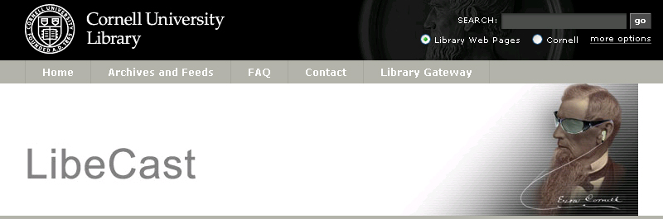

Figure 2. Uris Library Historical Tour Web site
http://libecast.library.cornell.edu/Uris

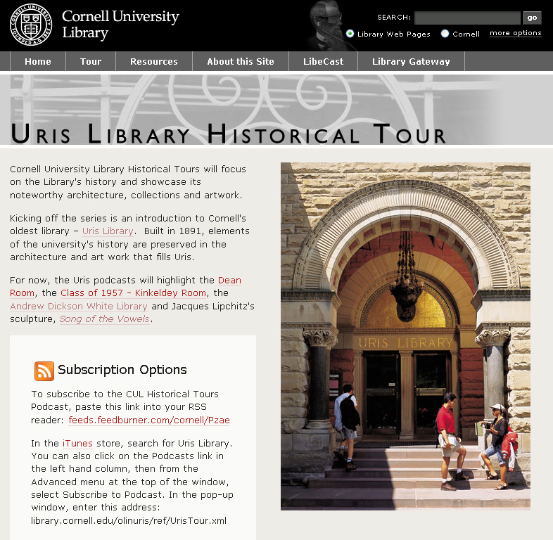
Figure 3. Research Minutes on YouTube
http://www.youtube.com/watch?v=uDGJ2CYfY9A

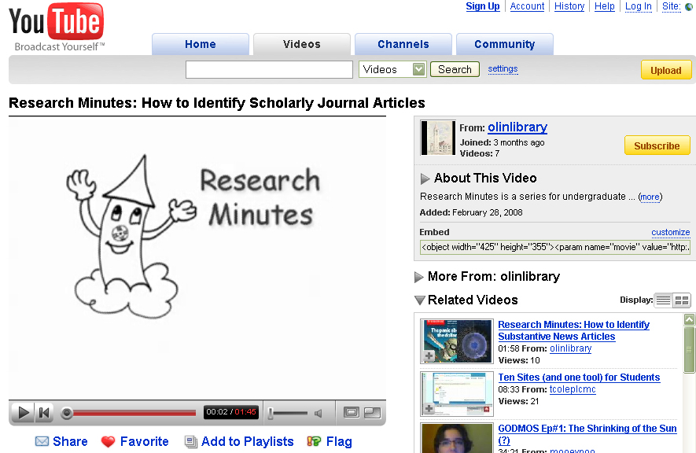

Figure 4. Research Minutes embedded into a course guide
http://guides.library.cornell.edu/picaresque

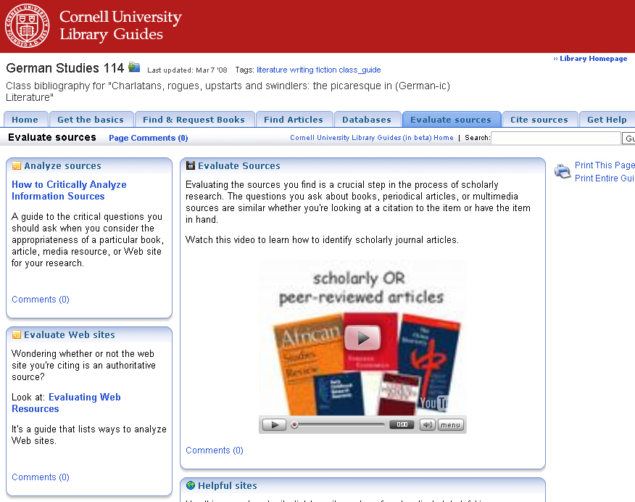

There is much data to support this contention. A PEW Internet and American Life Project survey taken in July 25, 2007 found that 76% of young adult (ages 18-29) Internet users watch or download videos online. 31% watch or download video on a normal day. “Teens and Social Media,” Pew Internet & American Life Project. http://www.pewinternet.org/pdfs/PIP_Teens_Social_Media_Final.pdf (accessed March 3, 2008).
We were fortunate in being able to collaborate with our library’s communications department, who produced the attractive, well-crafted delivery web site with its “earbudded” Ezra Cornell logo. 2007 was Ezra Cornell’s bicentennial year, and the library was delighted to capitalize on the university-wide celebration of its founder’s birthday. See Figure 1, below.
A wealth of material is available on the Web to learn about podcasting and digital media. Two guides we found particularly helpful were Jeffrey Frey, “The Why and How of Podcasting,” EDUCAUSE Southwest Regional Conference 2007, http://www.educause.edu/ir/library/pdf/SWR07068.pdf (accessed March 5, 2008), and “ELI Discovery Tool: Guide to Podcasting,” EDUCAUSE Learning Initiative, http://www.educause.edu/guidetopodcasting (accessed March 5, 2008).
Sites referenced: http://ecommons.library.cornell.edu, http://libecast.library.cornell.edu, http://www.apple.com/itunes/store/podcasts.html
Statistics gathering methods included Feedburner, http:// www.feedburner.com, and Google Analytics, http://www.google.com/analytics.
We continue to re-imagine the format and structure of our orientation tours. Deborah Lee has offered an interesting alternative we are considering implementing. “Even the ubiquitous library tour could be developed with particular audiences in mind. In an academic environment, one podcast tour might be developed for the freshmen writing their first composition paper, another for graduate students at the dissertation stage, and yet another for new faculty on campus.” Deborah Lee, “iPod, You-pod, We-pod: Podcasting and Marketing Library Services,” Library Administration & Management 20.4 (Fall 2006): 206-208.
In addition to discussing podcasting at length, Campbell addresses the potential of “rich media” or multimedia skills in higher education. Gardner Campbell, “There’s Something in the Air: Podcasting in Education.” EDUCAUSE Review Nov.-Dec. 2005: 33-46. http://connect.educause.edu/Library/EDUCAUSE+Review/TheresSomethingintheAirPo/40587. (accessed March 1, 2008).
The original content for the paper version of “Distinguishing Scholarly from Non-Scholarly Periodicals: A Checklist of Criteria” was developed by Joan Ormondroyd and the staff of Uris Library at Cornell in the 1980s, and it has continued to evolve ever since. Linked to the research tutorial in step six, “Evaluate What You Find,” the online version of the guide can be found at http://www.library.cornell.edu/olinuris/ref/research/skill20.html
Sites referenced: http://www.youtube.com/, http://www.library.cornell.edu/olinuris/ref/tutorialsguides.html
Throughout the creation process we used a wiki to record our ideas and develop a “best practices” guide. That guide allows us to share our technical knowledge with colleagues and contribute our newfound knowledge to professional development, encouraging others to produce their own podcasts or vodcasts. The long-term goal is to foster a sustainable podcast/vodcast program to promote the library’s services and collections, but we’ve found that using a Web 2.0 technology also promotes a Web 2.0 core philosophy: collaboration.

